Post Award Amendments Reference Sheet
The purpose of this reference sheet is to provide a brief guide on how to initiate post award amendment applications and access in-progress post award amendment applications from inside the eRA system.

What are Post Award Amendments?
Post award amendments are modifications to your grant that require an application submission and federal approval given in the form of a revised Notice of Award (NOA). Post award amendment types available in eRA Commons include:
- Budget Revision
- Carryover Request
- Change in Scope
- Key Personnel Changes
- Merger, Transfer, etc.
  - Also used for Successor in Interest actions
- No-Cost Extension
- Organization Change
  - Change of organization information. For changes of the organization itself, use Merger, Transfer, etc.
Please note that a non-competing continuation is not a post award amendment. For more information on continuations please access https://www.samhsa.gov/grants/continuation-grants.

Initiating a new Post Award Amendment application
Note: You must be the Project Director (PD) of the grant or be a Signing Official (SO) with the grantee organization to initiate Post Award Amendments for a grant.
- Log into eRA Commons (https://public.era.nih.gov/commons) with your username and password
- Access the Non-Research tab
- Select the sub-option Manage Post Award Amendments
  - If you have the SO role, enter search criteria and click Search
- In the Action column for the appropriate award number, click on Initiate… to view a drop-down menu of possible post award amendment types.
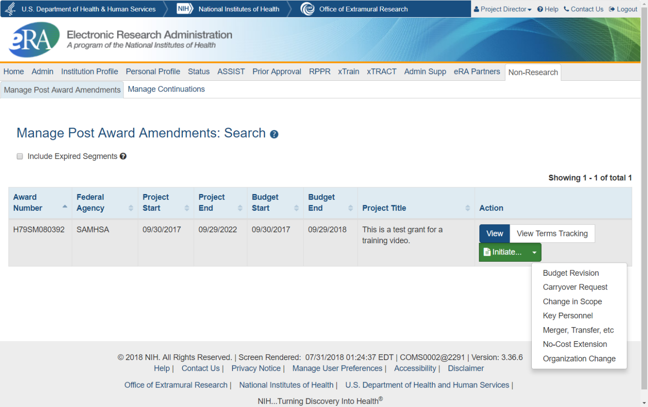
- Click on the desired post award amendment type, which will open an application in ASSIST, and begin the post award amendment application
  - Keep track of the Application Identifier on the Summary tab to access your incomplete application at a later time/date.
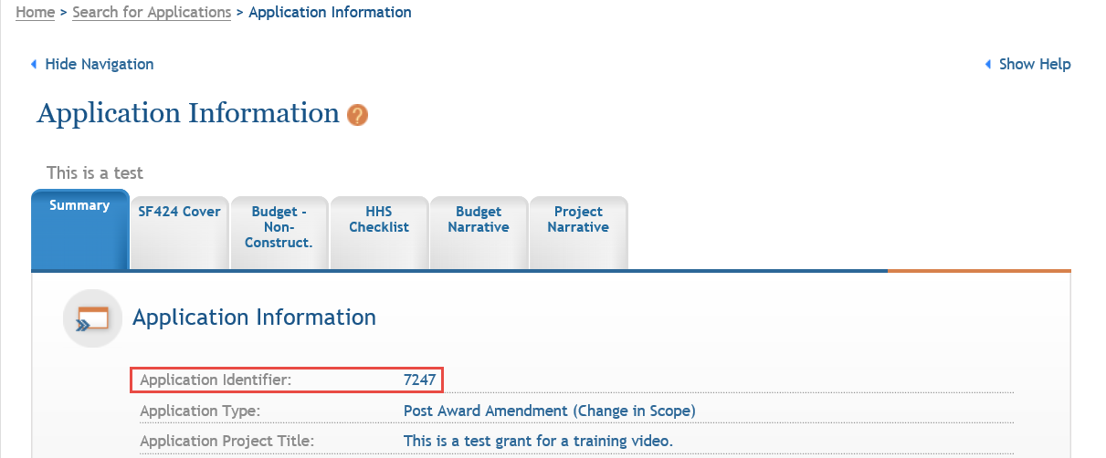
  - When you have completed the required forms and are ready to submit the application, you will need to complete the submission process described below.

Adding and Removing Post Award Amendment application forms
You may wish to add additional forms to applications before submitting them. To do this, follow the steps below:
- From the Application Information page, click the Add Optional Form action button on the left
- Select your desired form from the dropdown
- Click Submit Query to add the form
To remove a form, open the form to begin editing it and use the Remove Form button.
Note: Be careful to only use the Remove Form action with optional forms you have added to avoid removing a required form. Your Amendment will not be processed without all of the required forms.

Accessing an In-Progress Post Award Amendment application to Edit or View
You can access and edit in-progress (prior to submission or view submitted) post award amendment applications in ASSIST using the steps below:
- Access eRA Commons
- Click on the ASSIST tab
- On the ASSIST homepage, click Search Applications
- Enter search criteria and click Search
  - If you have the Application Identifier, search using that. It will bring up only one result since it is unique for each application.

Managing access to Post Award Amendment applications
To work on a Post Award Amendment application, you must have access to it in ASSIST. By default, to access and edit the application you will need one of the following roles:
- Signing Officials (SO) of the grantee organization
- Administrative Officials (AO role in eRA Commons) of the grantee organization
- The Project Director (PD) identified in the application
Signing Officials may also add, modify, or remove access for other users. Follow the steps below to change access for other users:
- While viewing your post award amendment application in ASSIST, click the Manage Access Action button on the left side of the page.
- To Add a new user, click on the Add New User button
  - Enter their Commons username into the Username field
  - Click Submit
  - Assign them access levels
  - Click Save
- To Edit an existing user, click on their username in the User column
  - Adjust their access and click Save to change their access
  - Click Revoke All Accesses to remove all access for that user

Submitting Post Award Amendment applications
To submit an application, you will need to be a Signing Official (SO) and will need to be able to enter Grants.gov Authorized Organizational Representative (AOR) credentials by having that role yourself, having the AOR enter their credentials, or by obtaining the credentials from the AOR and entering them.
Once you submit a post award amendment application, you will not be able to un-submit it, revise it, or copy it in ASSIST.
To submit an application, follow the steps below:
- Access the application you are ready to submit
- Click Update Submission Status in the Actions list on the left
- Select Ready for Submission in the status dropdown
- Either enter a comment and click Add Comment or click Continue without adding a comment.
  - These are comments for your organization’s reference and are not sent to SAMHSA.
- Click the Submit Application button
- Click Submit to confirm you would like to submit your post award application
- Enter your Grants.gov Authorized Organization Representative (AOR) credentials
- Click Enter

Post Submission Steps
After your Post Award Amendment is submitted, the Project Director and Business Official, as well as the SAMHSA GPO and GMS, will be notified by email. The email will include the Grant Number, Project Director name, the Amendment Type, and other relevant information.
You can continue to monitor the status of your application by accessing the Post Award Amendments View page. To do so, follow these steps:
- Log into eRA Commons (https://public.era.nih.gov/commons) with your username and password
- Access the Non-Research tab
- Select the sub-option Manage Post Award Amendments
  - If you have the SO role, enter search criteria and click Search
- In the Action column for the appropriate award, click View to display amendments associated with that grant award.
- You will be able to view all submitted amendment applications as well as the amendment status of each amendment application.

Amendment Statuses:
- Submitted: The application has been submitted and successfully received by SAMHSA.
- In Review: SAMHSA staff have begun to review the application.
- Disapproved: The amendment application has been disapproved.
- Awarded: The amendment application has been approved and a new notice of award has been issued.

Contacts:
- Budget and grant-specific questions: contact your assigned Grants Management Specialist (GMS)
- Program-related questions: contact your assigned Grants Project Officer (GPO)
- Technical questions: contact the eRA Service Desk
Web: eRA Service Desk Support
Toll-free: 1-866-504-9552, option 6 for SAMHSA queue
Phone: 301-402-7469, option 6 for SAMHSA queue
Hours: Mon-Fri, 7 a.m. to 8 p.m. Eastern Time

