Contents

Purpose of this Document 1

Policy Background 2

Data Flow of Direct Vendor Entry in HSS/ASSIST 3

Logging in to eRA Commons 3

Finding a Contract Project to Edit 4

Adding a New Study 6

Editing an Existing Study 7

Deleting an Existing Study 8

Adding an Inclusion Enrollment Report (IER) to a Study 8

Editing an Existing Inclusion Enrollment Report (IER) 10

Deleting an Existing Inclusion Enrollment Report (IER) 10

Validating and Submitting an Application 11

Editing an Application After Submission 11

Appendix: Assigning a PI to a Contract Project 12

# Purpose of this Document

eRA has developed the capability to allow direct vendor entry of inclusion data into the Human Subjects System/ASSIST. This new capability streamlines processes, allows for secure data transfer, and harmonizes processes for grants and contracts.

# Policy Background

* Women and members of racial and ethnic minority groups must be included in all NIH-funded clinical research studies unless there is a compelling rationale for exclusion.
* NIH-defined phase 3 clinical trials must be designed to permit analysis by sex or gender, race and ethnicity.
* Individuals of **all ages** must be included in NIH human subjects research unless there are scientific or ethical reasons not to do so.
* Submission of individual-level participant data in progress reports is required.

For more information, visit the following websites:

* NIH Inclusion of Women and Minorities Website
  + Public: <https://grants.nih.gov/policy/inclusion/women-and-minorities.htm>
* NIH Inclusion Across the Lifespan Website
  + Public: <https://grants.nih.gov/grants/funding/lifespan/lifespan.htm>
* HSS Training
  + Public: <https://era.nih.gov/erahelp/HSS_External/>
* Contact:
  + NIH Contracting Officer
  + OER inclusion mailbox – [inclusion@mail.nih.gov](mailto:inclusion@mail.nih.gov)

# Data Flow of Direct Vendor Entry in HSS/ASSIST

The diagram below illustrates how inclusion data moves through eRA modules using the workflow outlined in this document.

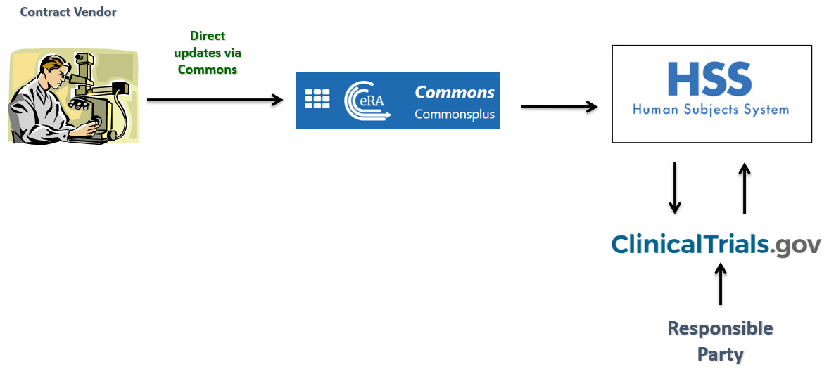

Figure 1 Direct Vendor Entry into HSS/ASSIST

# Logging in to eRA Commons

1. Using a web browser, navigate to <https://public.era.nih.gov/commonsplus>. The eRA Commons login screen appears.
2. Log in with your normal login method; for more information, see [Logging into eRA Commons](https://www.era.nih.gov/erahelp/Commons/#Commons/access/login.htm).

# Finding a Contract Project to Edit

Use these instructions if you logged into eRA Commons, but you were not automatically directed to the *Contract/Project Information* screen for a contract project.

1. On the eRA Commons home screen, click the **Status** module button.

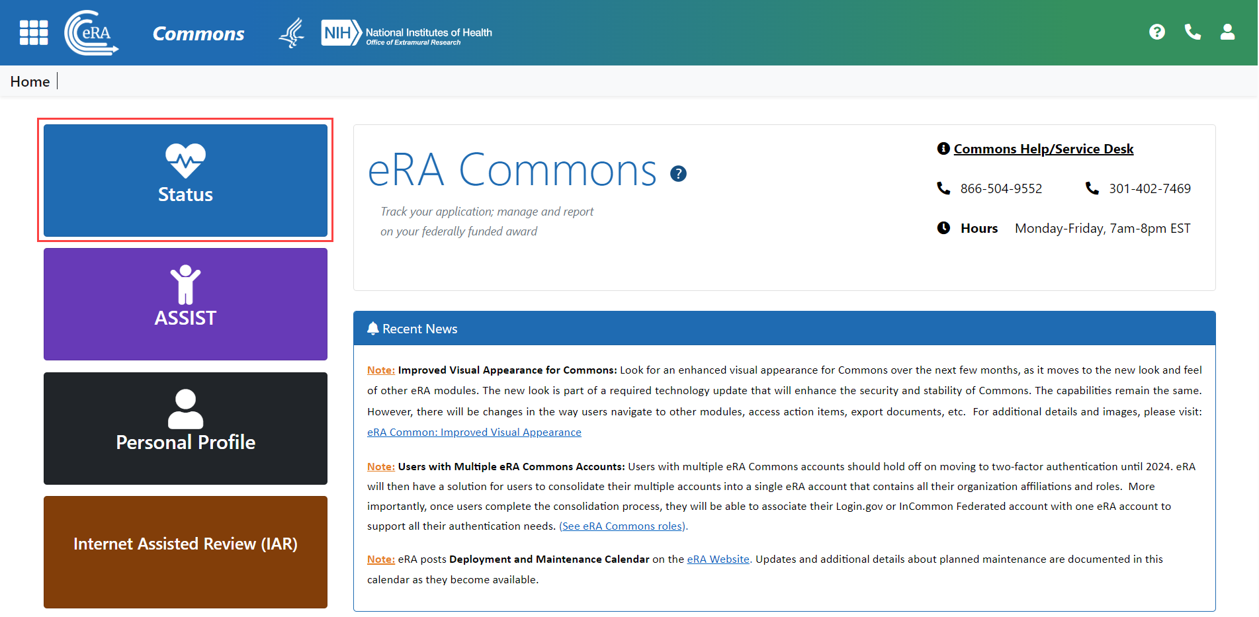

Figure 2 eRA Commons home screen with the Status module button outlined

1. If you are a **PI**:
   1. On the *Status: PI Search* screen click **List of Applications/Awards**.

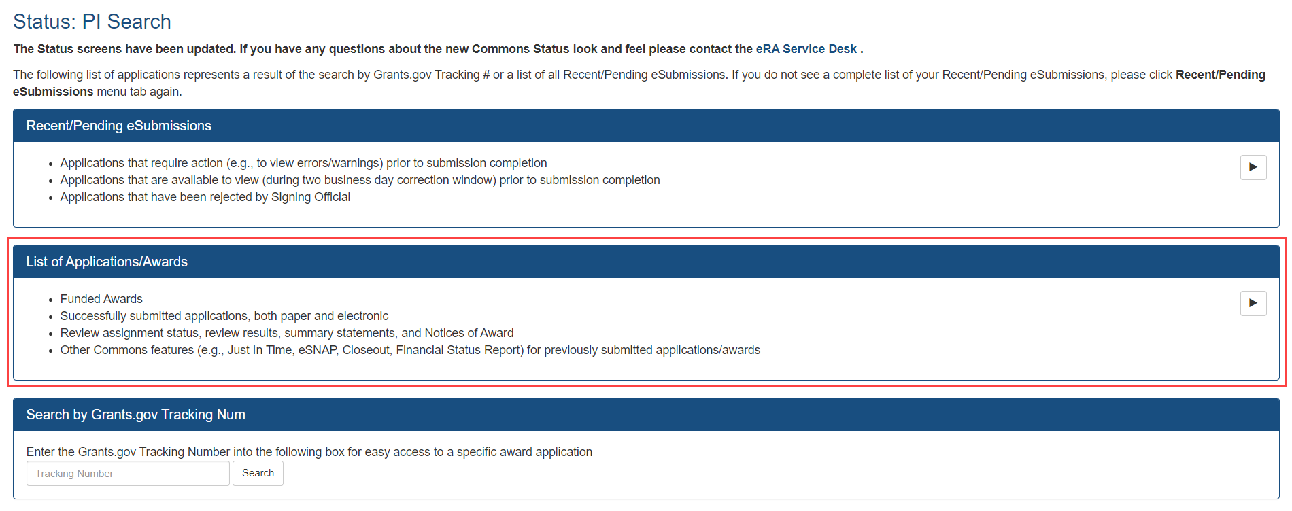

Figure 3 Status screen for a PI with the List of Applications/Awards outlined

**NOTE**: You must be assigned as a PI to see the contract in the List of Applications/Awards. If you do not see the contract in the list, contact the SO to be assigned. Instructions for assigning a PI can be found in the Appendix: Assigning a PI to a Contract Project at the end of this document.

* 1. In the list that appears, locate the contract and click its Expand button **Expand** button to view the list of assigned contract projects.

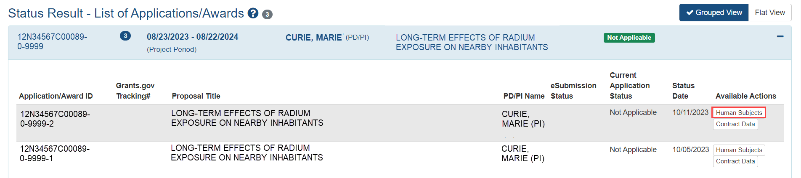

Figure 4 List of Applications/Awards with the Human Subjects button outlined

* 1. Click the **Human Subjects** button in the **Available Actions** column for the appropriate contract project.

1. If you are an **SO**:
   1. Use the *Search* screen to locate the contract.
   2. Click the three-dot ellipsis Actions button three-dot ellipsis **Actions** button and select **Human Subjects**.

The application is opened in ASSIST/HSS.

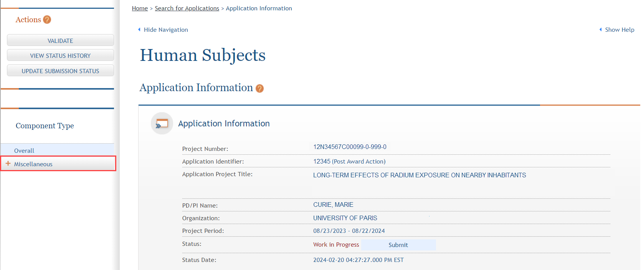

Figure 5 Application Information screen in ASSIST

1. Click the **Miscellaneous** button in the Actions pane on the left side of the screen. The components, or contract projects, of the application are listed.
2. Select the component, or contract project, you wish to edit. The Component Information screen is displayed.

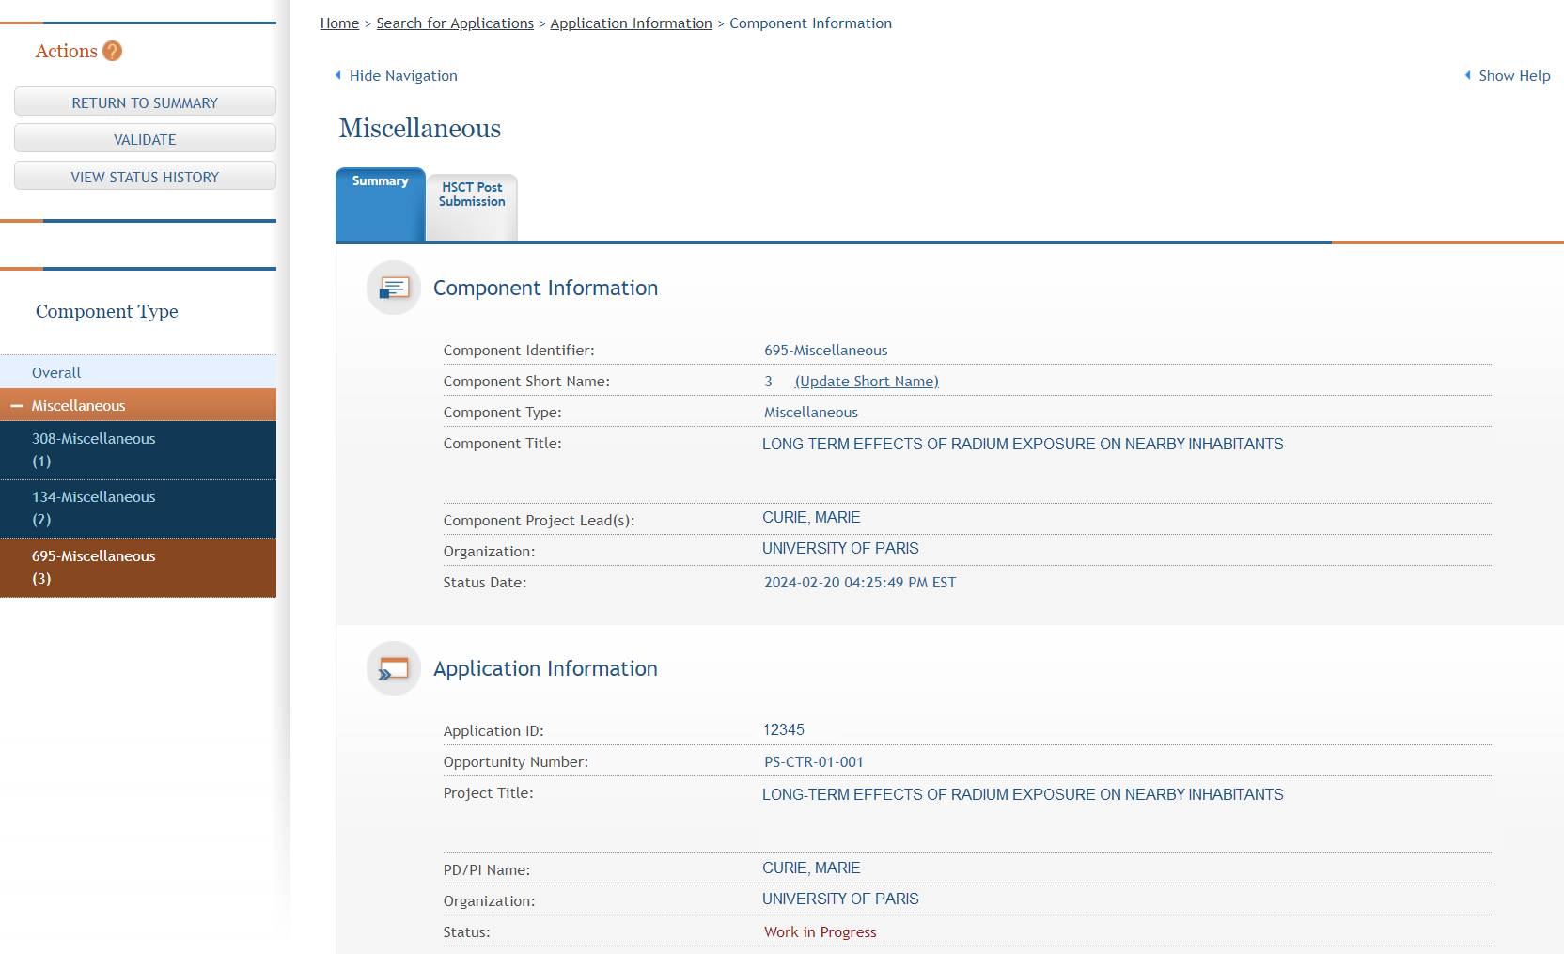

Figure 6 Component Information screen in ASSIST

1. Click the **HSCT Post Submission** tab.
2. Click the **Edit** button. The tab is displayed in Edit mode.

# Adding a New Study

1. Complete the steps in the Finding a Contract Project to Edit section to open the HSCT Post Submission tab in Edit mode.
2. Click the **Add New Study** button. The Clinical Trial Post Submission - Study Record screen is displayed.
3. Complete the study record. Note that required fields are marked with a red asterisk (**\***).

**NOTE**: For detailed instructions on the Study Record form fields, refer to the following topics from the [ASSIST online help](https://www.era.nih.gov/erahelp/ASSIST/Content/About_Help_SystemExt.htm):

* [**Section 1 - Basic Information:**](https://www.era.nih.gov/erahelp/ASSIST/Content/ASSIST_Help_Topics/3_Form_Screens/PHS_HS_CT/StdyRcrd_Sect_1.htm) Title, exemptions, and Clinical Trial information.
* [**Section 2 - Study Population Characteristics:**](https://www.era.nih.gov/erahelp/ASSIST/Content/ASSIST_Help_Topics/3_Form_Screens/PHS_HS_CT/StdyRcrd_Sect_2.htm) Focus, Demographics, IERs, etc.
* [**Section 3 - Protection and Monitoring Plans:**](https://www.era.nih.gov/erahelp/ASSIST/Content/ASSIST_Help_Topics/3_Form_Screens/PHS_HS_CT/StdyRcrd_Sect_3.htm#top) Information regarding PHS issues, data and safety monitoring, and team structure.
* [**Section 4 - Protocol Synopsis:**](https://www.era.nih.gov/erahelp/ASSIST/Content/ASSIST_Help_Topics/3_Form_Screens/PHS_HS_CT/StdyRcrd_Sect_4.htm) Study design, purpose, interventions, metric parameters, etc.
* [**Section 5 - Other Clinical Trial-related Attachments:**](https://www.era.nih.gov/erahelp/ASSIST/Content/ASSIST_Help_Topics/3_Form_Screens/PHS_HS_CT/StdyRcrd_Sect_5.htm) Additional attachments that do not fit the other sections.
* [**Section 6 - Clinical Milestone Plan:**](https://www.era.nih.gov/erahelp/ASSIST/Content/ASSIST_Help_Topics/3_Form_Screens/PHS_HS_CT/StdyRcrd_Sect_6.htm)Used to record milestone dates and whether study is an applicable clinical trial under FDAAA.

1. Use one of the buttons at the bottom of the form to save the study:

* **Save and Keep Lock**: Save your changes and keep the form locked from changes by other users.
* **Save and Release Lock**: Save your changes and release the form to be edited by others.
* **Save and Add**: Save your changes and add another study.

The study is added to the record. Alternatively, you may use the buttons below to discard changes:

* **Cancel and Release Lock**: Cancel any changes made and release the form to be edited by others.
* **Remove Study**: Remove the current study and save the deletion.

# Editing an Existing Study

1. Complete the steps in the Finding a Contract Project to Edit section to open the HSCT Post Submission tab in Edit mode.
2. Click the **Edit** button for the appropriate study to open it in Edit mode.
3. Modify the study record as appropriate.
4. Use one of the buttons at the bottom of the form to save the study:

* **Save and Keep Lock**: Save your changes and keep the form locked from further changes.
* **Save and Release Lock**: Save your changes and release the form to be edited by others.
* **Save and Add**: Save your changes and add another study.

The study is added to the record. Alternatively, you may use the buttons below to discard changes:

* **Cancel and Release Lock**: Cancel any changes made and release the form to be edited by others.
* **Remove Study**: Remove the current study and save the deletion. Please note that once a study is submitted to NIH, this button is no longer available.

# Deleting an Existing Study

1. Complete the steps in the Finding a Contract Project to Edit section to open the HSCT Post Submission tab in Edit mode.
2. Click the **Edit** button for the appropriate study. The Clinical Trial Post Submission - Study Record screen is displayed.
3. Click the **Remove Study** button at the bottom of the screen. A confirmation screen is displayed.
4. Click the **Continue** button. The study is deleted, but the application must be saved to complete the deletion.
5. Use one of the buttons at the bottom of the form to save the application:

* **Save and Keep Lock**: Save your changes and keep the form locked from further changes.
* **Save and Release Lock**: Save your changes and release the form to be edited by others.
* **Cancel and Release Lock**: Cancel any changes made and release the form to be edited by others.

Please note that once a study has been submitted to NIH, it cannot be deleted by an external user. To delete an already-submitted study, please contact the NIH Contracting Officer.

# Adding an Inclusion Enrollment Report (IER) to a Study

1. Complete the steps in the Finding a Contract Project to Edit section to open the HSCT Post Submission tab in Edit mode.
2. Click the **Edit** button for the appropriate study. The Clinical Trial Post Submission - Study Record screen is displayed.
3. In section **2.9**, click the **Add New Inclusion Enrollment Report** button.
4. If an IER already exists, an informational message is displayed. Choose from the following actions:

* Click the **OK** button to add a new IER.
* Click the **Cancel** button to return to the study record screen. Refer to the Editing an Existing Inclusion Enrollment Report (IER) section for instructions on editing an IER.
* If no message is displayed, continue to the next step.

1. Complete the Inclusion Enrollment Report form. Note that required fields are marked with a red asterisk (**\***).
2. Complete the **Planned** table by entering the counts into the fields. The totals are calculated automatically as data are entered.

The **Cumulative (Actual)** table can be completed in one of two ways: entering data manually, or uploading a .csv file. The .csv file is required for all prospective research funded from solicitations posted on or after January 25, 2019.

1. To enter data manually, enter the counts into the fields. The totals are calculated automatically as data are entered.
2. To upload a .csv file:
   1. Click the Save and Keep Lock button to save the form.
   2. Click the Download Participant Level Data Template button to download a properly formatted .csv file.
   3. Open the .csv file, enter data about the study participants, and save the file.

**TIP**: Follow the instructions in the [Participant-Level Data Template Tip Sheet](https://grants.nih.gov/sites/default/files/Participant-level%20data%20template%20tip%20sheet.pdf) carefully to ensure that the .csv file is completed correctly. There are troubleshooting tips at the end of the tip sheet, as well as links to a [video](https://youtu.be/yOFa40XhcKs), [video transcript](https://era.nih.gov/sites/default/files/Human-Subject-Addressing-Errors-Video-Transcript.pdf), and the [eRA help desk page](https://www.era.nih.gov/need-help).

* 1. Click the **Upload Participant Level Data Attachment** button.
  2. Click the **Choose File** button. The Open screen is displayed.
  3. Navigate to the save location of the file and double-click it.
  4. Click the **Submit** button. The .csv file is validated and its data are added to the **Cumulative (Actual)** table.

1. Use one of the buttons at the bottom of the form to save the study:

* **Save and Keep Lock**: Save your changes and keep the form locked from further changes.
* **Save and Release Lock**: Save your changes and release the form to be edited by others.
* **Save and Add**: Save your changes and add another IER.

Alternatively, you may use the buttons below to discard changes:

* **Cancel and Release Lock**: Cancel any changes made and release the form to be edited by others.
* **Remove Report**: Remove the current IER and save the deletion.

# Editing an Existing Inclusion Enrollment Report (IER)

1. Complete the steps in the Finding a Contract Project to Edit section to open the HSCT Post Submission tab in Edit mode.
2. Click the **Edit** button for the appropriate study. The Clinical Trial Post Submission - Study Record screen is displayed.
3. In **2.9**, click the **Edit** button for the IER you wish to modify.
4. Modify the IER as appropriate.
5. Use one of the buttons at the bottom of the form to save the IER:

* **Save and Keep Lock**: Save your changes and keep the form locked from further changes.
* **Save and Release Lock**: Save your changes and release the form to be edited by others.
* **Save and Add**: Save your changes and add another study.
* **Cancel and Release Lock**: Cancel any changes made and release the form to be edited by others.
* **Remove Study**: Remove the current study and save the deletion.

The modified IER is saved to the record.

# Deleting an Existing Inclusion Enrollment Report (IER)

1. Complete the steps in the Finding a Contract Project to Edit section to open the HSCT Post Submission tab in Edit mode.
2. Click the **View** button for the appropriate study. The Clinical Trial Post Submission - Study Record screen is displayed.
3. In **2.9**, click the **View** button for the IER you wish to delete. The IER screen is displayed.
4. Click the **Edit** button at the top of the IER screen. The screen is refreshed.
5. Click the **Remove Report** button at the bottom of the screen. A confirmation screen is displayed.
6. Click the **Continue** button. The IER is deleted, but the study record must be saved to complete the deletion.
7. Use one of the buttons at the bottom of the form to save the study record:

* **Save and Keep Lock**: Save your changes and keep the form locked from further changes.
* **Save and Release Lock**: Save your changes and release the form to be edited by others.
* **Save and Add**: Save your changes and add another study.
* **Cancel and Release Lock**: Cancel any changes made and release the form to be edited by others.

# Validating and Submitting an Application

1. Click the **Validate** button in the Actions pane on the left side of the screen. The application data are checked for errors.
2. If errors are found, use the results list to locate the errors, correct them, and save the application, then repeat the validation check.

Once the validation check indicates that all validations passed, you are ready to submit the application.

1. Click the **Update Submission Status** button in the Actions pane on the left side of the screen.
2. Click the **Select the new status** drop-down and select **Ready for Submission**.
3. Perform one of the following actions:
   1. If you wish to add a comment, enter it in the **Comment** field, then click the **Add comment** button. The comment is added and the application status is updated.
   2. If you do not wish to enter a comment, click the **or continue without adding a comment** link.

The Application Information screen is displayed and the Submit button is now available.

1. Click the **Submit** button at the bottom of the Application Information section. A confirmation message is displayed.
2. Click the **Submit** button. The application is submitted and the information is passed to the Human Subjects System.

# Editing an Application After Submission

If you need to make edits to an application that has been submitted, you must first change its submission status.

1. Complete the steps in the Finding a Contract Project to Edit section to open the application in ASSIST.
2. Click the **Update Submission Status** button in the Actions pane on the left side of the screen.
3. Click the **Select the new status** drop-down and select **Work in Progress**.
4. Perform one of the following actions:
   1. If you wish to add a comment, enter it in the **Comment** field, then click the **Add comment** button. The comment is added and the application status is updated.
   2. If you do not wish to enter a comment, click the **or continue without adding a comment** link.

The Application Information screen is displayed and the application is now editable.

1. Modify the application as needed, then validate and resubmit it.

# Appendix: Assigning a PI to a Contract Project

Any SO from your organization can assign a PI to a contract project.

**NOTE**: If the PI you wish to assign does not currently have an eRA Commons account, any SO for your organization can follow the directions in [Create or Edit a New Commons Account](https://www.era.nih.gov/erahelp/commons/#Commons/1_Admin/mgacct_create.htm) (<https://www.era.nih.gov/erahelp/commons/#Commons/1_Admin/mgacct_create.htm>).

1. On the eRA Commons home screen, click the **Status** module button.

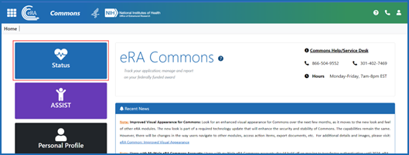

Figure eRA Commons home screen with the Status module button outlined

1. Use the *Search* screen to locate the contract.
2. Click the three-dot ellipsis Actions button three-dot ellipsis **Actions** button and select **Contract Data**. The *Contract/Project Information* screen is displayed.

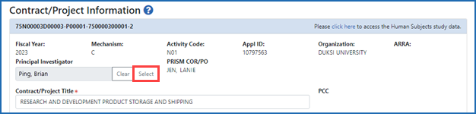

Figure 8: Select button next to Principal Investigator on Contract/Project Information screen

1. Click the **Select** button next to the **Principal Investigator** field.

The *PI Lookup* window appears.

1. Enter search criteria for first and last name and click the **Search** button.

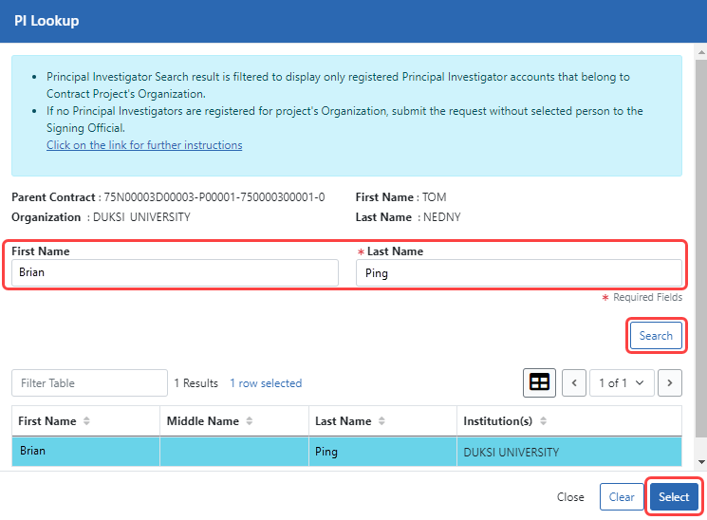

Figure 9: PI Lookup window after searching for a name, showing search criteria, Search button, and Select buttons outlined in red

1. From the search results table at the bottom, select a new PI to assign the contract project to and click the **Select** button.

**NOTE:** If the PI you are looking for is not in the results list, you (or any SO) can create an eRA Commons account for the PI, so that they can be assigned to a contract project. See [Create or Edit a New Commons Account](https://www.era.nih.gov/erahelp/commons/#Commons/1_Admin/mgacct_create.htm).

1. At the bottom of the *Contract/Project Information* screen, click the **Save Project** button. The PI is assigned to the contract project.