ICO Quick Reference Guide

Step One: Accessing ICO
- When the IMPAC II Client Server Applications shortcut is clicked, you will see a list of IMPAC II Applications
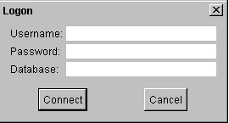
- Click on IC Operations
  - The application will begin to load… this may take a few moments
  - Log in to the Oracle server using your IMPAC II user name and password
  - In the Database text box enter IMPP
  - Click Connect
- Click the List of Applications radio button
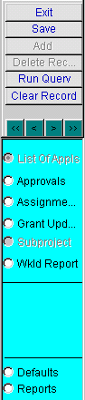
- The General Query Screen will be displayed

Step Two: Query the Applications for Approval
- In the Query Parameters box, enter the serial number of the wanted application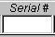
- Click the Run Query button on the toolbar
- The application’s records will be returned
ICO Toolbar
- Select the current application year’s record
- This is based on the Type 5 Application’s Grant Number
- Click the Approval radio button on the toolbar
- The Program Approval Screen will be displayed
- Click on the Checklist Items box and select the appropriate radio button for each item. Explanations should be entered in the Sign Off Comments
- In the Sign Off box, click the Sign Status check box
- Your Electronic signature and the date will be displayed in the signature text box

Step Three: Exiting
- Click the Exit button on the toolbar
- You will return to the General Query screen
- Click the Exit button on the toolbar
- You will exit ICO
- You can not exit ICO by using the Close Window button on the Title bar of any ICO window

Adding Sign Off Comments for Grants Management Specialist
This can be done either before or after you approve the application
- Place cursor on the PO signature row
- Click the Sign Note radio button located on the toolbar
- The Signature Comment dialog box will be displayed
- Enter the notation in the text box
- Click Save

Adding Scientific Comments
- Click on the Program Note radio button located on the toolbar
- The Program Comment dialog box will be displayed
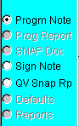
- Enter the notation in the text box
- Click Save, and then Print if you want a printout

To print the report, click radio button called PO Worksheet on
the Program Approval screen; this will print pertinent grant info,
answers to checklist items, and sign-off comments.

