Reviewers can locate the critique template associated with their application in one of 3 places in IAR:

- On the List of Applications screen, by clicking on the three-dot ellipsis icon and select the ‘Critique Template’ link

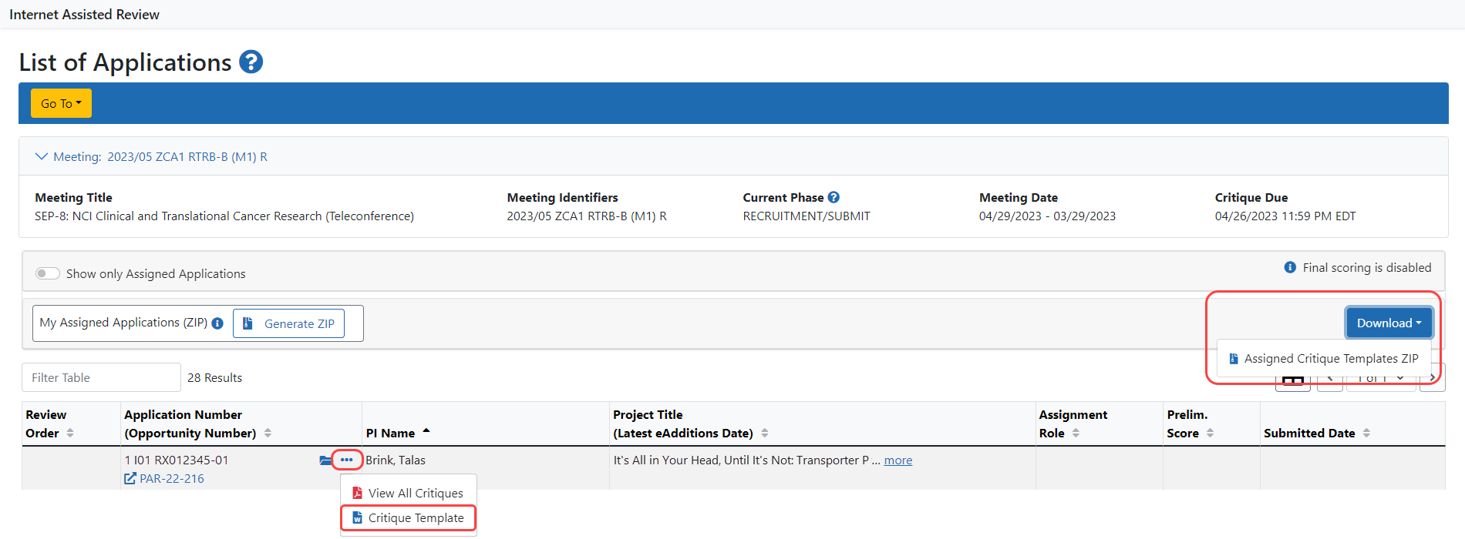

Note: A reviewer can also download templates for all his or her assigned applications by clicking on the Download button and selecting ‘Assigned Critique Templates ZIP.’ However, this link will only show if all the applications in the meeting have associated templates. It doesn’t matter if the reviewer’s assigned applications all have associated templates. If there are any unassigned or assigned applications with no associated template, the link for the zip file will not appear.

- On the List of My Assigned Applications screen, by clicking on the three-dot ellipsis icon and select the ‘Critique Template’ link

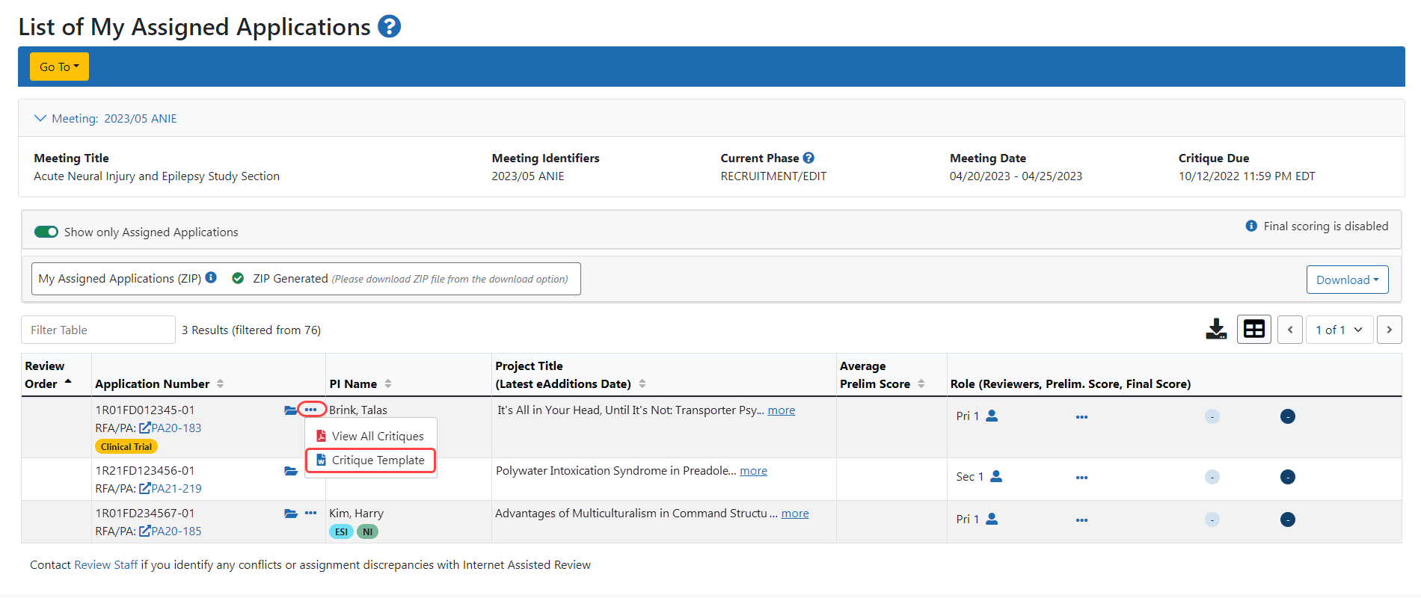

- In the Meeting Materials folder, click on the three-dot ellipsis icon and selecting the ‘View Template’ link
